STARFLEET International:   
Project Earth Wilderness / Park Cleanup

**Sample Sponsorship Letter**

**Subject:** Join Us in Keeping Our Parks Clean – STARFLEET Project Earth Wilderness/Park Cleanup Sponsorship Opportunity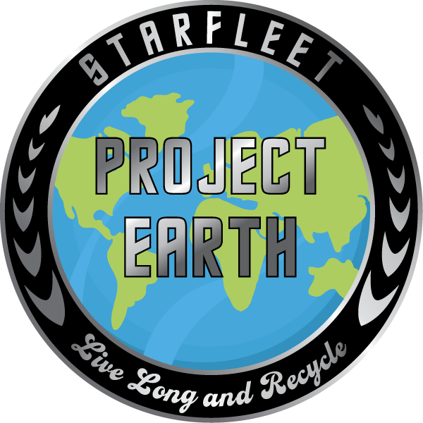

Dear [Sponsor's Name],

We are reaching out to invite you to be part of an exciting environmental initiative, **STARFLEET Project Earth: Wilderness/Park Cleanup**, happening between **April 22 and May 11, 2025**. As part of a global effort to clean and restore our natural spaces, STARFLEET members in [Your Location] will be gathering volunteers to remove litter, recycle waste, and beautify local parks and wilderness areas.

We would love for your organization to support our mission by providing donations or in-kind contributions such as:

* Park entry passes for volunteers
* Work gloves and garbage bags
* Loaning cleanup tools like rakes, pickup claws, and shovels
* Discounted accommodations for multi-day events and meal sponsorships
* Bottled water or bagged lunches for volunteers
* Waste disposal support to ensure collected garbage is handled properly
* Small prizes for our volunteers

In return, your business will receive recognition in several ways:

* Featured in our event promotions (social media, flyers, newsletter and local press releases)
* A heartfelt thank you certificate recognizing your contribution to environmental stewardship

Would you be interested in partnering with us for this impactful event? We’d love to discuss how we can collaborate to make a lasting difference. Please feel free to contact me at [Your Contact Information].

Thank you for your time and consideration. We look forward to working together to keep our parks and wilderness areas beautiful!

Sincerely,  
[Your Name]  
[Your STARFLEET Chapter/Region]  
[Your Contact Information]